Two Magical Snapshots in Time
Alexander Blumke

Seattle, August 1995: The second Magic: the Gathering World Championships. The winning player, a 26-year-old literature student, fourth member of the Swiss National Team, prevailed with a 3-color, 63-card deck based on a hand denial and board control strategy. The new World Champion built his deck the night before the tournament. The prizes for his victory - a box of Legends boosters, a Hurloon Minotaur jacket, a couple of Arabian Nights, Antiquities and Beta boosters - are definitely a treat for any enthusiastic Magic player.

Tokyo, August 2000: The seventh Magic: the Gathering World Championships. The new World Champion, last year's Professional Player of the Year, Jon Finkel, is widely recognized as the finest Magic strategist in the world. Finkel prevailed 3-2 in the finals against Bob Maher, this year's Professional Player of the Year, with a fine-tuned, fast artifact deck that took the rest of the field by surprise. Both finalists played the same deck. The prize for his victory - over 30,000 USD - will cement Finkel's leading position in the game's life earnings ranking list.
Same game, five years apart.
Same game? It is still "Magic: the Gathering" for sure, but over the course of its seven years of existence, the name is nearly the only thing that didn't change. The two snapshots above illustrate quite accurately that further than changes in the game itself, further than rules renewals and card mechanic additions, the M:tG competition environment evolved a lot in the past five years.

The Past
When I became Magic: the Gathering World Champion in 1995, there was no metagame, to the point that the word "metagame" was unheard of among Magic players. Richard Garfield himself actually introduced this concept to Magic in his "Lost in the Shuffle" column featured in Duelist #5. The preparations for a tournament were the following: you built a deck of your own, tested it against the decks of a few friends, learned how to play it, fine-tuned it, and off you went to the tourney. At that time, you had no idea about what kind of decks you would face in a tournament, except that usually you would have to compete with mostly creature-based decks.
Then, at the tournament, you would play against people who, just like you, would have built a deck of their own. In 1995, Magic was still a one-on-one game: one mind against another, your strategy against the opponent's. In 1995, the most important skills in Magic were deck construction skills. Following that in importance were the actual playing skills, because at that time even the earliest players had had only one and a half years practice behind them, with no pro players to learn from, so that playing mistakes were not that uncommon. Most importantly, the world wide web was only starting to spread, which made information about tournament-winning decks and game strategy very scarce. This lack of information made everything a little more random, so that the fourth member of a small European country's National Team had just as much chance to win as the National Champion of Magic superpower America.
At the World Championships in 1995, the field was as unpredictable as it was diverse. In the course of the tournament, I played against a 4-color creature deck, B/u discard (twice), W/U control, G/R creatures/direct damage, R/B land destruction. In the quarterfinals, I faced mono green (with a creature range from Elf to Force of Nature); in the semis, I met Mark Justice's red control deck; and in the finals I got acquainted with W/r TurboPrison (the term hadn't been coined yet, but that's what Marc Hernandez's deck was).
Alexander Blumke
World Championships '95 (63 cards)
Main Deck |  | Sideboard
Creatures (6)  1 Royal Assassin  2 Sengir Vampire  3 Hypnotic Specter  Spells (32)  1 Balance  3 Dance of the Dead  1 Dark Banishing  4 Dark Ritual  3 Disenchant  1 Disrupting Scepter  4 Hymn to Tourach  2 Icy Manipulator  1 Land Tax  1 Mind Twist  1 Pestilence | 1 Power Sink  3 The Rack  1 Swords to Plowshares  1 Spirit Link  2 Terror  2 Zuran Orb  Land (25)  3 Adarkar Wastes  1 Bottomless Vault  4 Mishra's Factory  3 Plains  1 Strip Mine  12 Swamp  1 Underground River | 1 Blue Elemental Blast  1 CoP: Artifacts  1 CoP: Black  2 CoP: Red  4 Gloom  1 Land Tax  1 Magical Hack  1 Prismatic Ward  1 Sleight of Mind  2 Stromgald Cabal

The Present
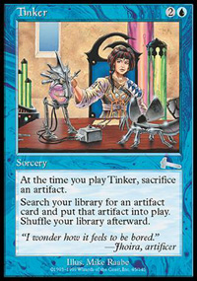
At the World Championships 2000, there was still diversity, but almost all deck archetypes had been revealed and publicized by reports from the tournaments preceding Worlds. These 9-10 decks had all been thoroughly defined and analyzed, and had been given names like Tinker, Suicide Black, Control Black, Accelerated Blue, Replenish, Ponza, Rebels, Angry Hermit, Stompy or Bargain. These decks were those a player would meet, and they formed the "metagame" of this year's Worlds' environment. In a way, it was like playing in an environment full of preconstructed decks.
The preparations of a motivated player for such a tournament were very different from what a player did in 1995. To do well today, one has to analyze this metagame in order to either identify the deck which has the highest win percentage overall and play it, or come up with a new deck that would beat most of the decks listed above - because, for instance, of its surprise factor. Finkel's and Maher's analysis allowed them to realize that few artifacts were played in the field, which naturally created an environment with few artifact removal cards in both the main decks and the sideboards. They logically concluded that playing a fast artifact deck would give them an edge over the rest of the field.

M:tG Skills in 2000
The most important factor in Magic nowadays is information, and the most important skills in Magic are information analysis skills, in Limited (you can find a lot of color-by-color, even card-by-card analysis of Sealed and Draft strategies on the net today) as well as in Constructed. After seven years of Magic, a large number of tournament players have mastered close to perfect playing skills, so that wins or losses are more often the result of deck strategies and luck of the draw than (im)perfect play. Deck construction skills are still good to have, but are not that important anymore because of the possibility of getting a successful strategy straight from the net.
Nowadays, the most skillful Magic analysts' quest for the holy grail is not "the perfect deck" anymore, but to outthink the metagame: knowing what is best to play is only part of it, because knowing that everybody knows something might make you come up with something entirely different.

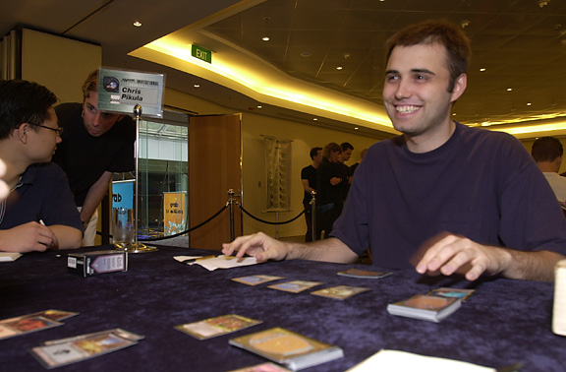
Information Analysis Skills.
Does that remind you of something? Wall Street. Stock markets. There too, information and information analysis skills have a paramount importance. There too, participants try to outthink the market, the "metagame," to gain some profit out of it. Chris Pikula, winner of the 1999 Invitational, is a successful stock options trader. How good would Zvi Mowshowitz be?

From Individual to Team-oriented
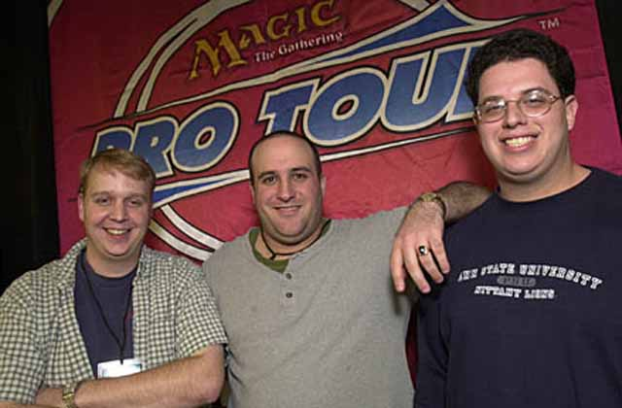
Because the amount of information is so large, an encompassing analysis of it, even for only one specific tournament, is quite difficult and time-consuming for one person to undertake. Besides, the creativity of M:tG's conceivers has spread the two basic formats of the game, Constructed and Limited, into so many branches (Sealed, Booster Draft, Rochester Draft, Standard, Extended, Block Constructed, and probably more in the future) that it is hard for a single person to remain competitive in all of them. Players started to realize they needed more than one mind to be able to handle this flow of information. The advent of the Pro Tour also motivated specialists in one of these formats to become competitive in the other formats, and they started looking for people to work with. Finally, people started to realize it was possible to come close to encompassing the deck possibilities of a limited environment like Block Constructed if enough persons get together to think about it. For all these reasons, and, more simply, also because of friendships, teams started to form. The Pacific Coast Legends was the first widely recognized team; Minions of Atog, Tongo Nation, The Legion, Deadguy, Mogg Squad, Your Move Games and hundreds of others followed. From an individual game, M:tG evolved into a team-oriented game, and the introduction of a team tournament on the Pro Tour last year actually reflects this evolution.

Doing Well on the Pro Tour
The emergence of information through internet portals like The Dojo, Meridian Magic or the Sideboard has made information available to everyone, decreasing the luck factor over the years and causing the best players emerge on top. The "best" players being a mix of analytical skills, play skills, amount of time put into the game, a web of connections as large and diverse as possible, and a team membership. In the list of top Pro Tour players, there is not one who does not meet these requirements.

An Open-ended Universe
Magic: the Gathering, unlike other games like Monopoly or Bridge but like stock markets or the world we are living in, is an open-ended universe, which means that information keeps coming in and keeps changing the game. Since its rules are on cards which are created regularly, it grows and evolves, and the M:tG of yesterday is quite different from the M:tG of tomorrow. All games have rules changes in the course of time, for sure, but many (especially sports) resist such changes for the sake of "tradition" (unlike strange tribes in Wimbledon or Vatican, we can thank Magic's conceivers to have chosen evolution over tradition). M:tG is unique in the way that, through new cards, it builds in its own rules changes in the course of time. Thus its rules, not unlike ADN strings, include their own evolution. In this respect, Magic: the Gathering is as alive as a game can be.

The Future of Magic
The future of Magic: the Gathering is definitely creativity. Richard Garfield provided us with a really exciting game which has a wonderful ability to morph, and new formats - like those played at the Invitationals for instance - are in the nature of the game and will hopefully not be overlooked by tournament organizers in the future for the sake of standardization. Duplicate Sealed, Solomon Draft and Backdraft are among the most fun and interesting formats to have been conceived for Magic, and it would be sad to leave that fun to only sixteen players once a year.
Anyway, if the DCI and Magic R&D do not rest on their laurels, we can bet that the M:tG World Championships snapshot 2005 will be quite different from the 1995 and 2000 pictures - but certainly as interesting.

